**Free secure web deployment**



Index

introduction 1

Get the domain 1

Get the hosting 2

Get the ssl certificate 3

Configuration 6

# introduction

In this document we can find how to deploy a website for free, using freenom, 000webhost and cloudflare. We can also find a .js script to remove the 000webhost bottom banner in the github repository <https://github.com/josemariaaguilera/free-https-website.git>

# Get the domain

We can get a free domain in <https://my.freenom.com>

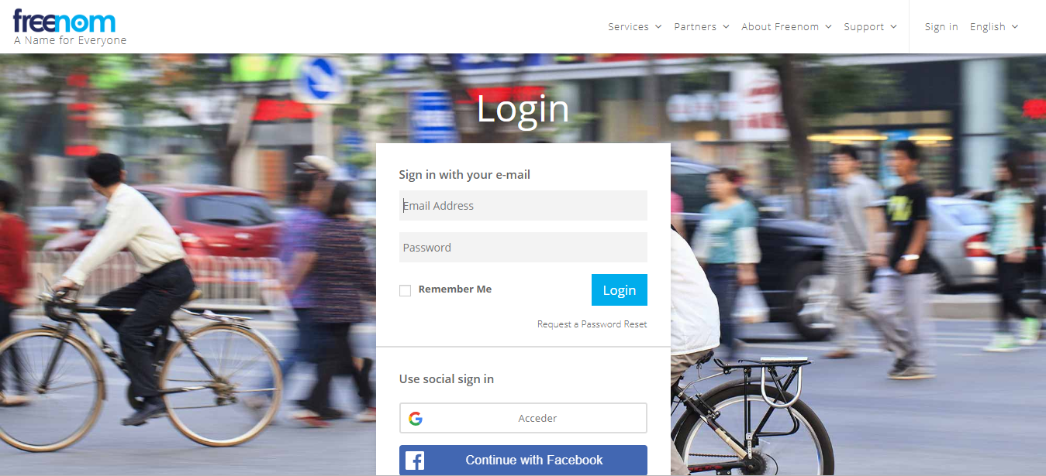

Just sing up a new account or sing in whit our Google or Facebook account.

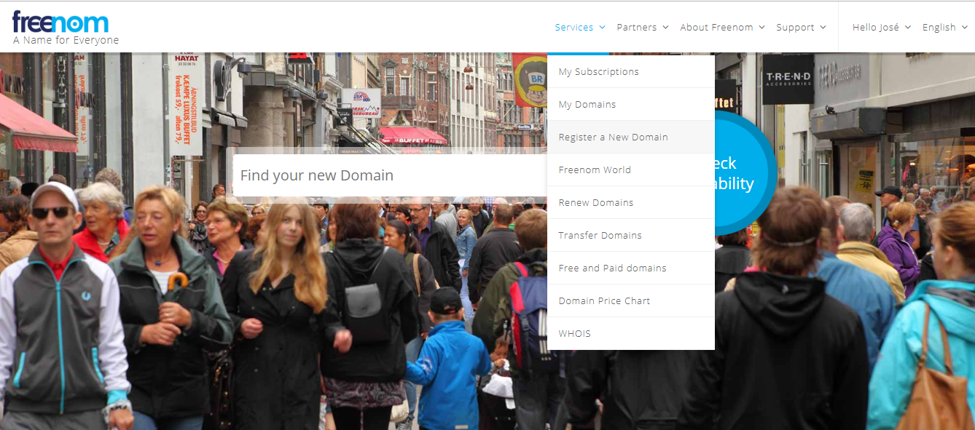

after singing in, we click on services 🡪 register a new domain. We can select some free extensions like .tk, .ml, .ga… or pay for another domain like .com.

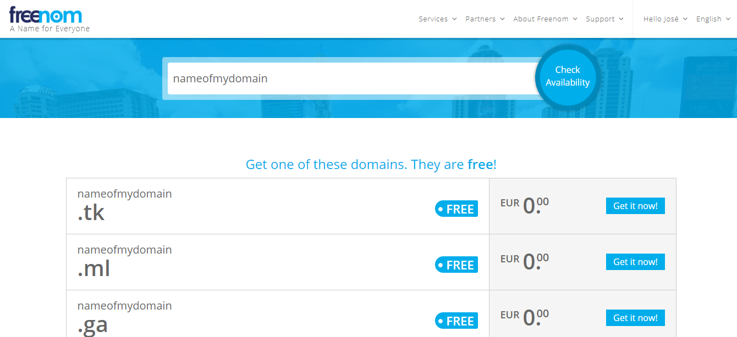

Once we have registered our domain, we need to get our hosting.

# Get the hosting

We can get a free hosting in <https://www.000webhost.com/free-website-sign-up>



Does not matter the name we choose for the 000webhost domain, because we are going to change it for our freenom domain later.

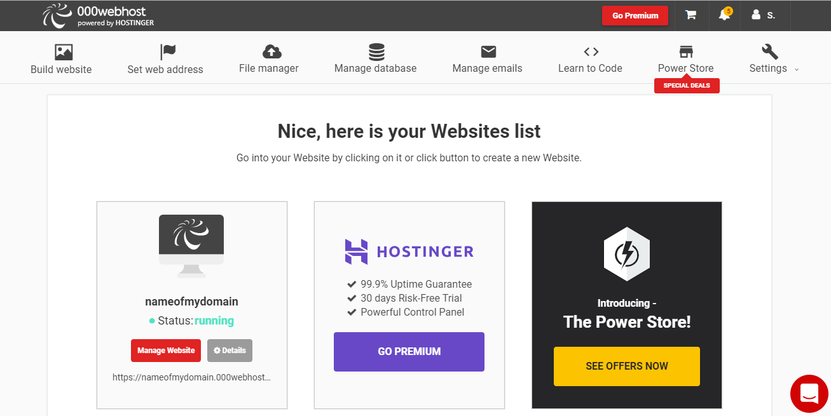

Once we have register in 000webhost and we have created a website we can upload our own page with the file maganer in the public_html folder.

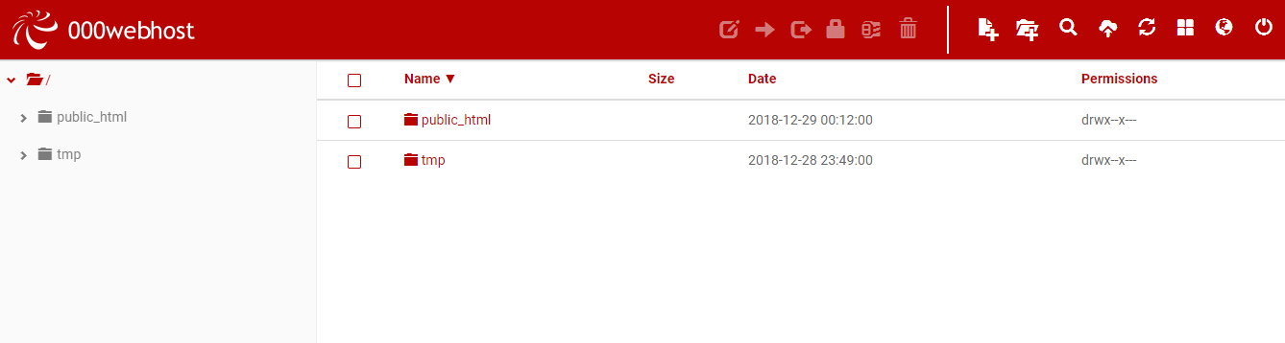

Later we need to get the ssl certificate.

# Get the ssl certificate

We will use the ssl certificate of cloudflare, for this, the first thing is creating an account in <https://dash.cloudflare.com/sign-up>

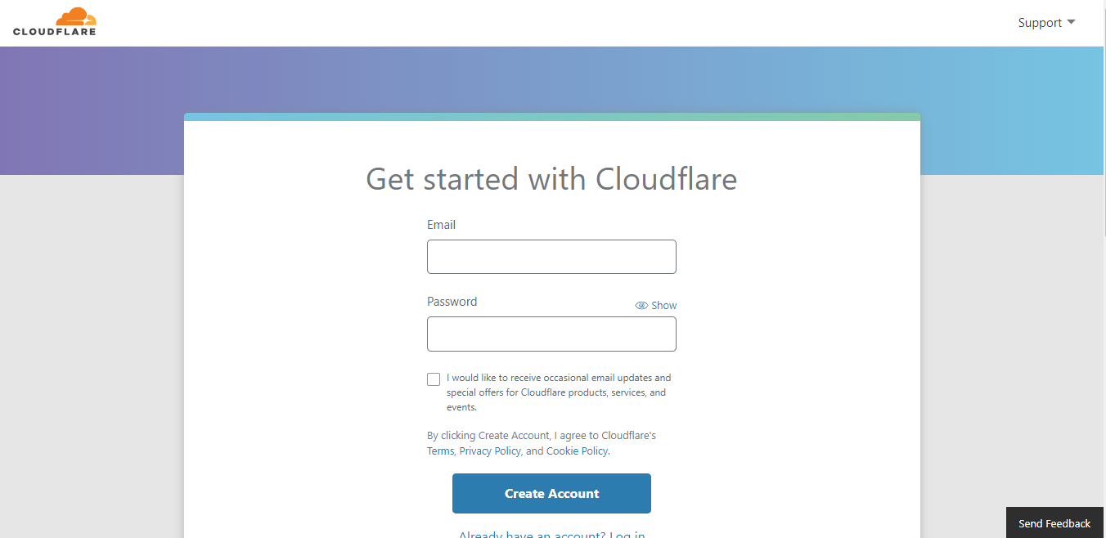

Following we add a site.

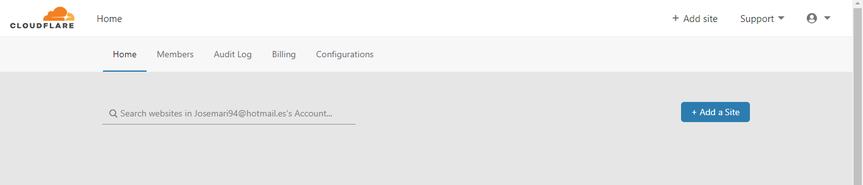

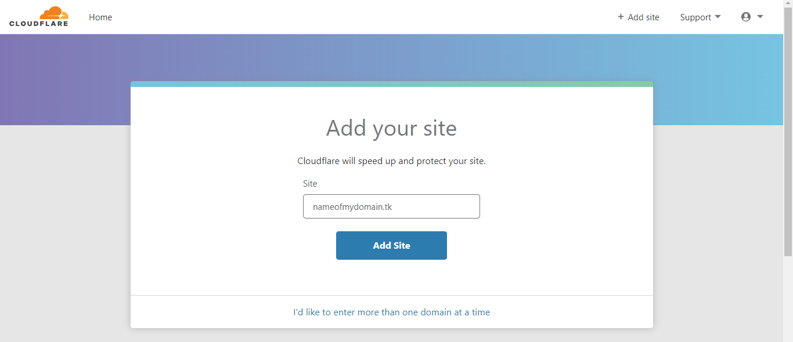

We must write our registered domain.

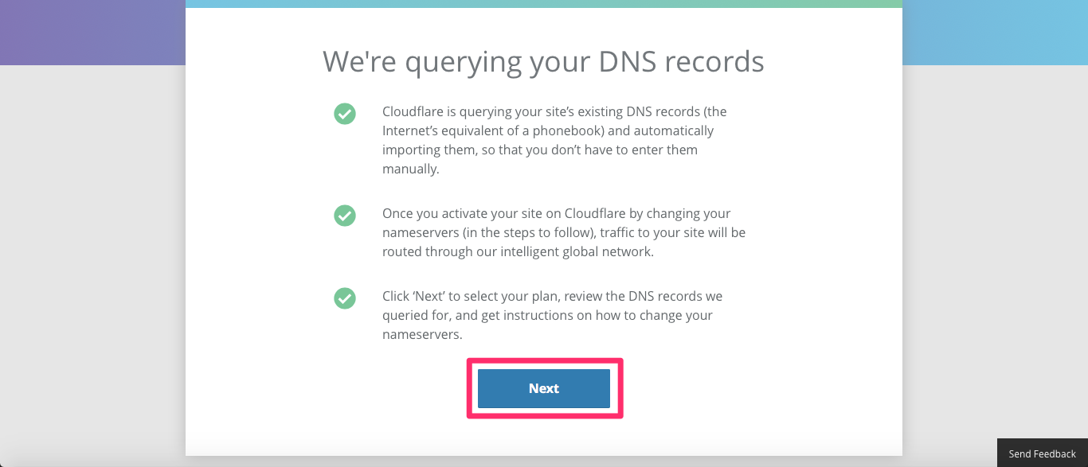

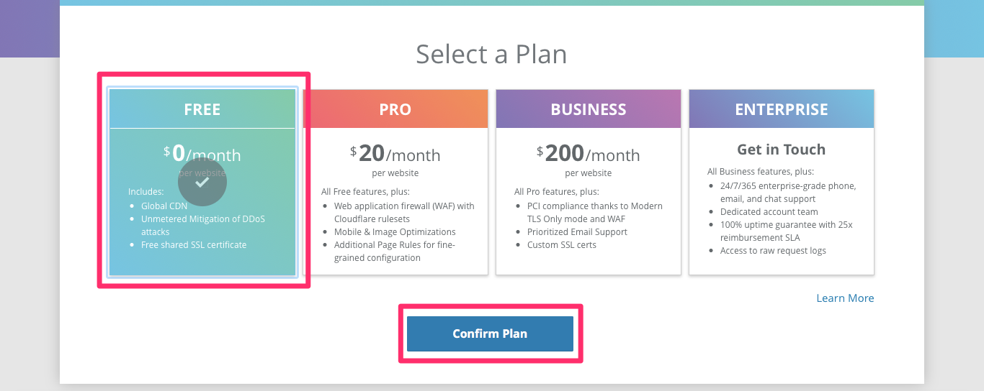

Now we need to make sure that the free plan is selected.

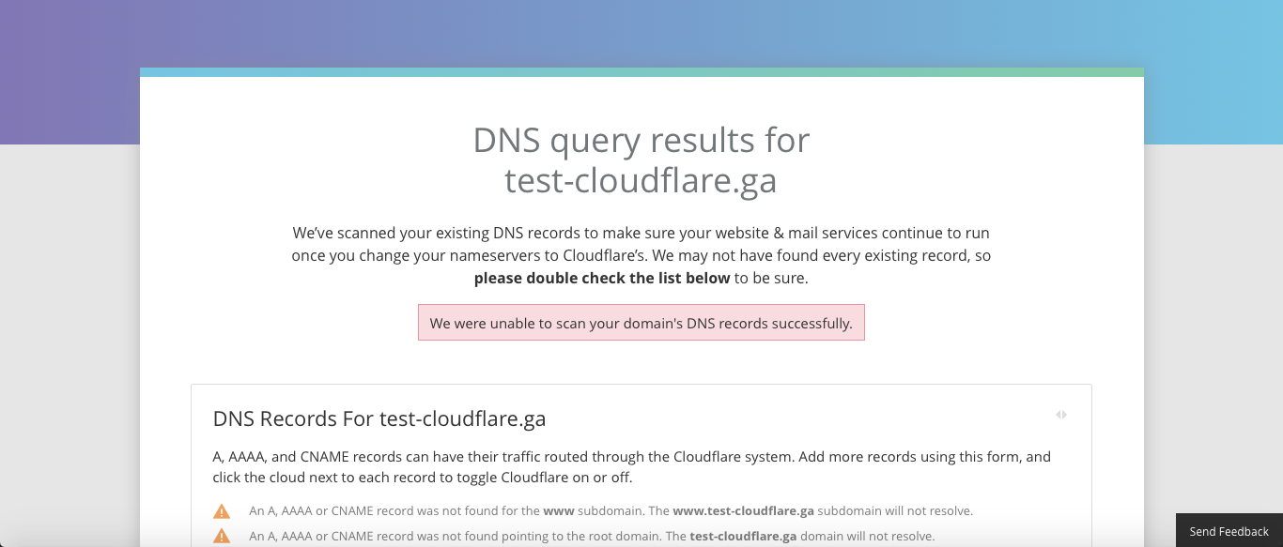

On this next screen, we need to click “Continue” in the bottom part of the page.

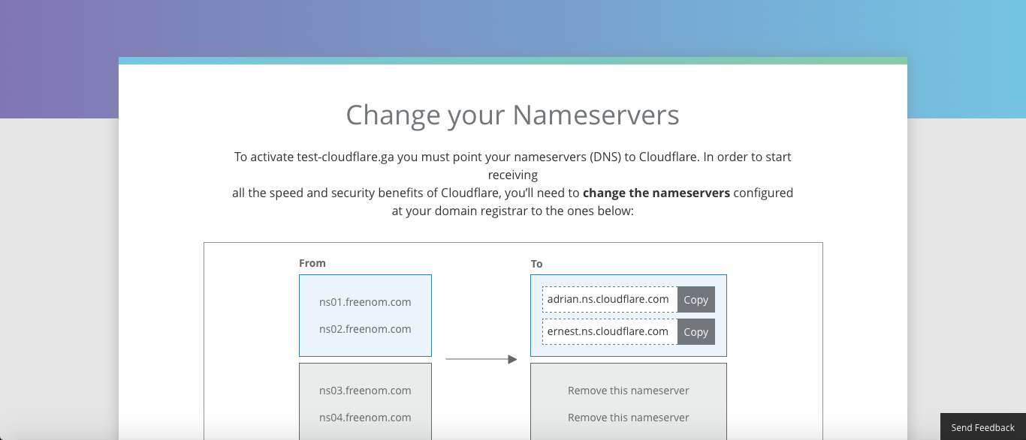

On this point, we have all we need, but we need configure it. Don’t close this screen.

# Configuration

We need to change the freenom configuration with the nameservers cloudflare give us.

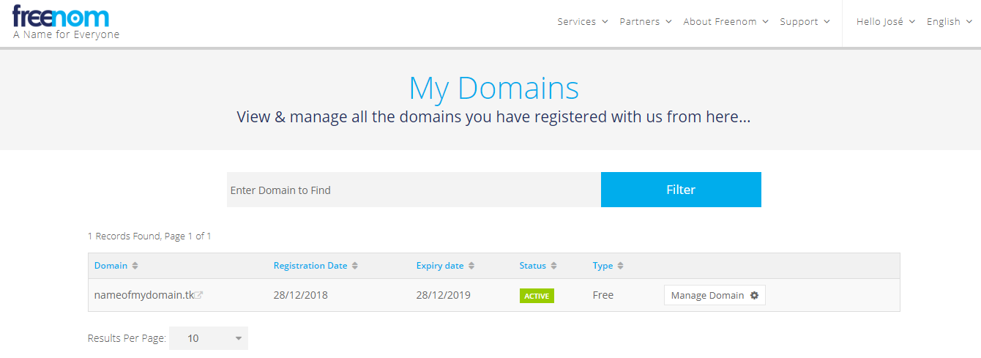

For configurate the nameservers we click services 🡪 my domains and click on manage domain.

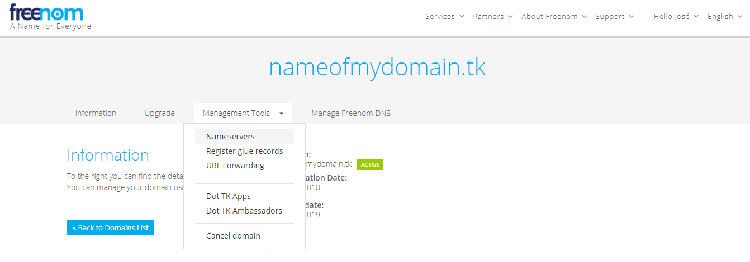

Then we click on management tools 🡪 nameserver

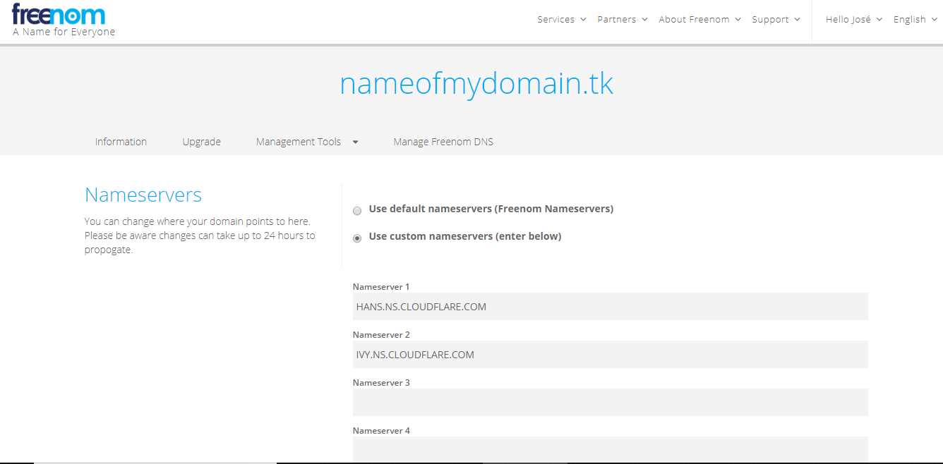

And write the cloudflare nameservers here.

When we do this click “Continue” on the cloudflare screen.

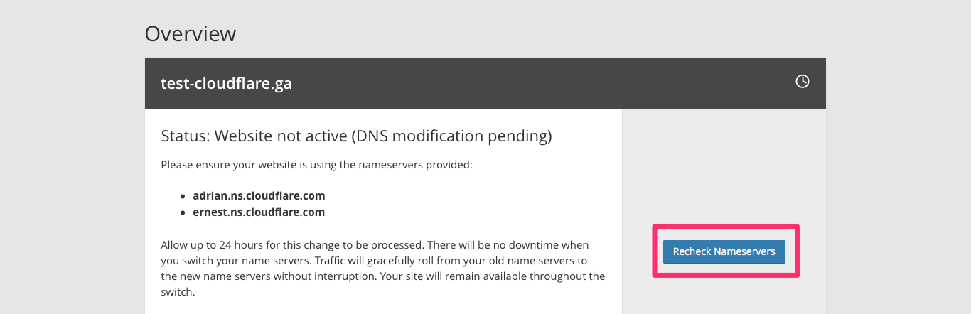

And click on recheck nameservers.

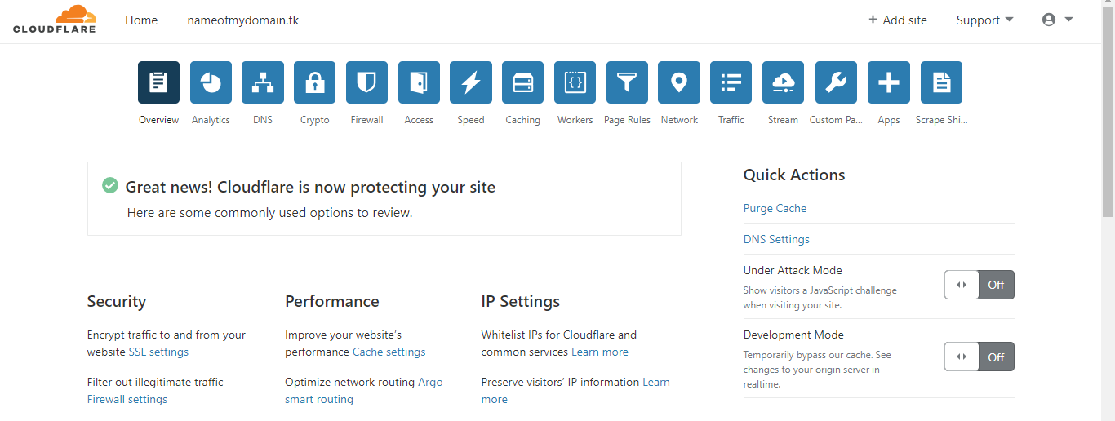

Once the nameservers changes have been verified, we’ll see this screen.

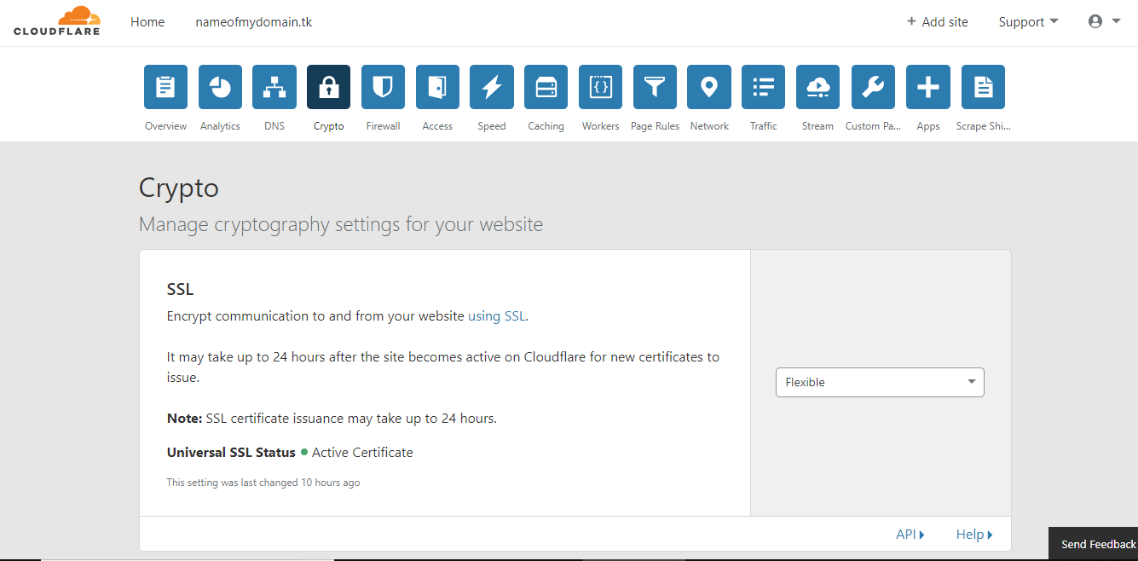

Next, we click on the crypto menu and select Flexible.

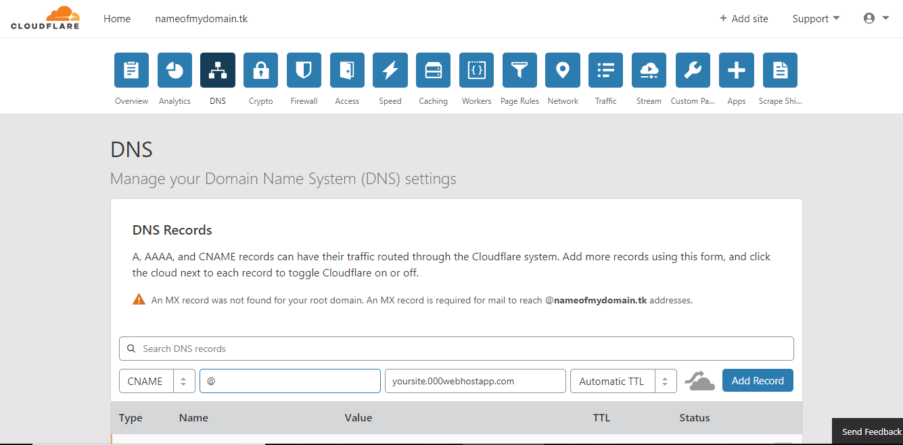

Then, we need to add 2 CNAME registers:

* "@" points to "yoursite.000webhostapp.com"
* "www" points to "yoursite.000webhostapp.com"

Make sure that the cloud is gray and not orange, or otherwise 000webhost will not accept the domain name.

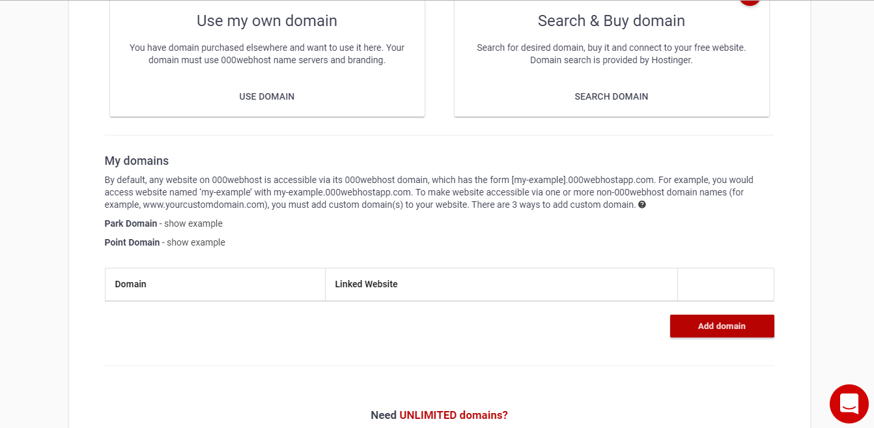

Then in 000webhost cpanel click on “set web address” and we will add the domain here.

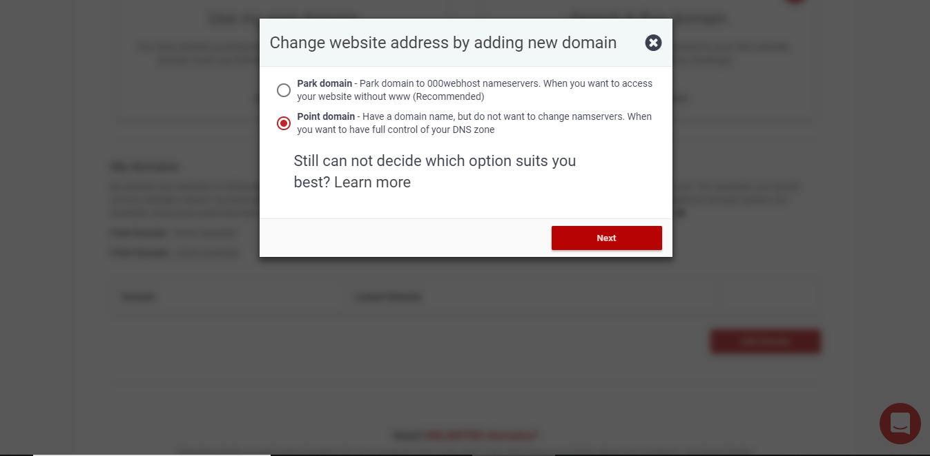

Select point domain.



And write our domain.

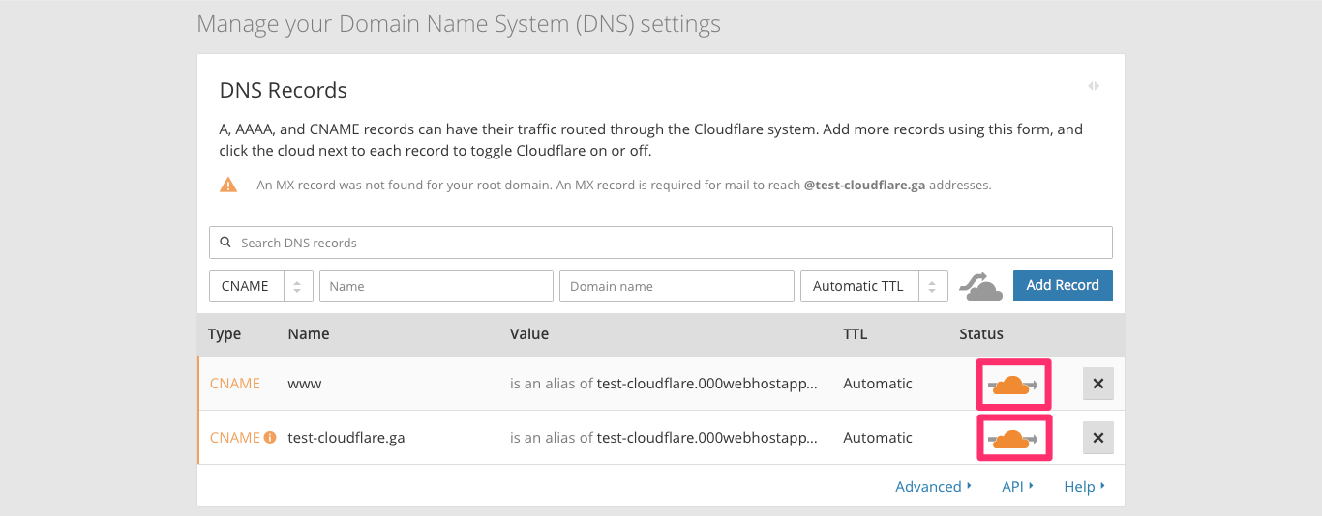

To finish the configuration, go to the cloudflare dns configuration and click on the gray clouds of the recently added CNAME registers to turn them orange.

If we do everything good our website now run with https.